James Liu

CS 4495, Computer Vision

Fall 2014

Problem Set 4

**Problem Set 4, Question 1, Part 1, Image 1**

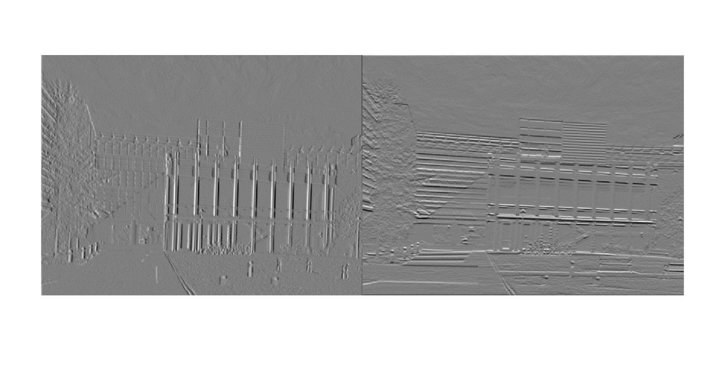

Gradient-pair image for transA. X gradient on the left, Y gradient on the right.

**Problem Set 4, Question 1, Part 1, Image 2**

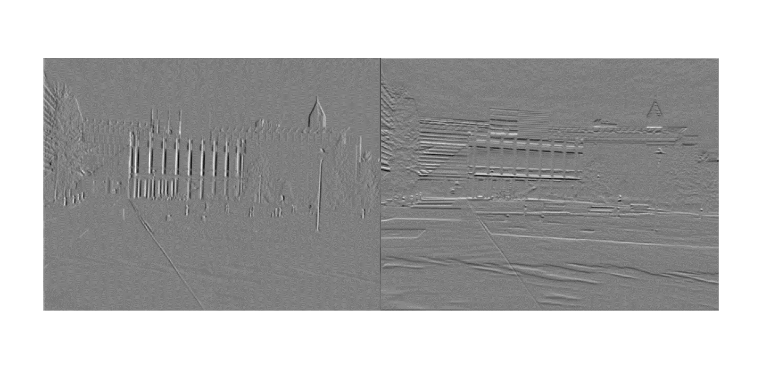

Gradient-pair image for simA. X gradient on the left, Y gradient on the right.

**Problem Set 4, Question 1, Part 2, Image 1**

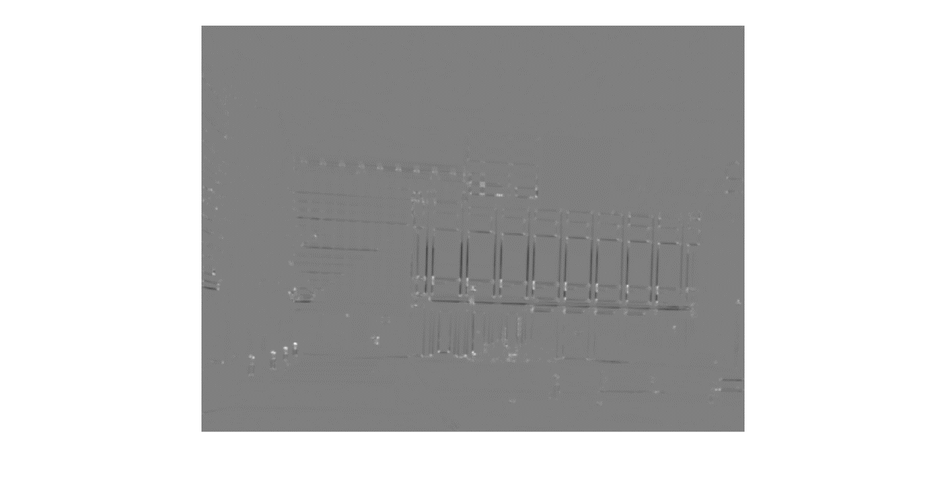

Harris value image of transA. Note how edges are outlined in black, and corners in white.

**Problem Set 4, Question 1, Part 2, Image 2**

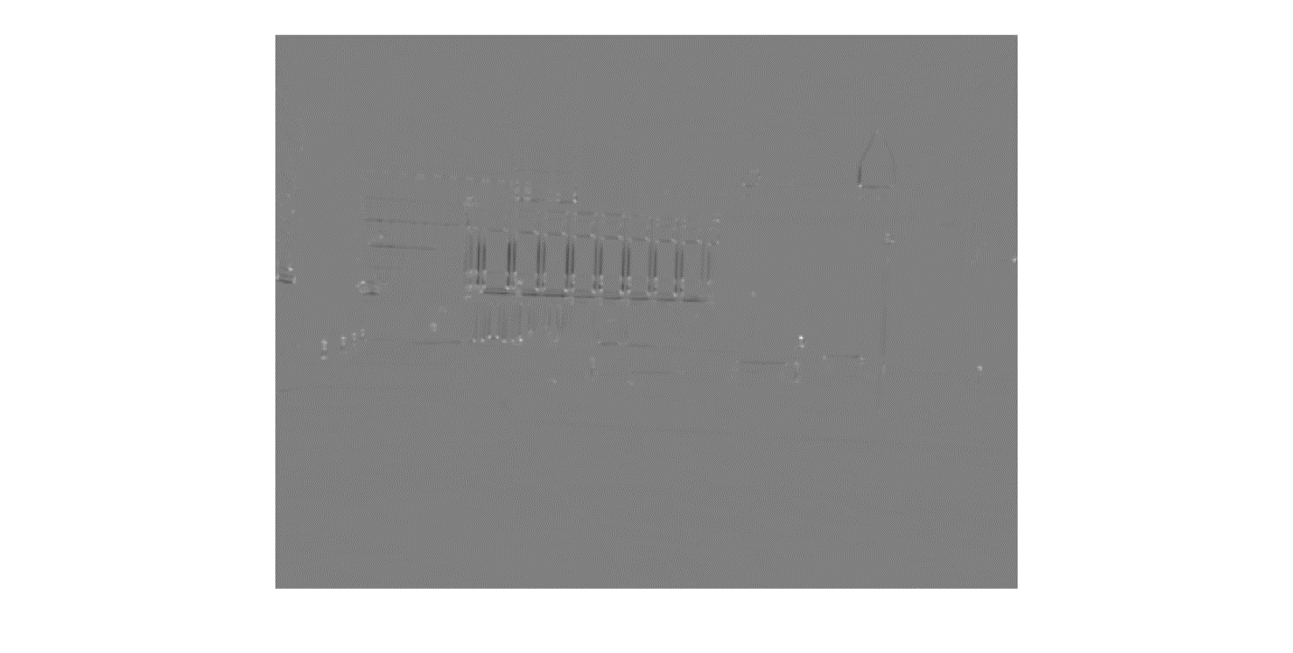

Harris value image of simA. Note how edges are outlined in black, and corners in white.

**Problem Set 4, Question 1, Part 3, Image 1**

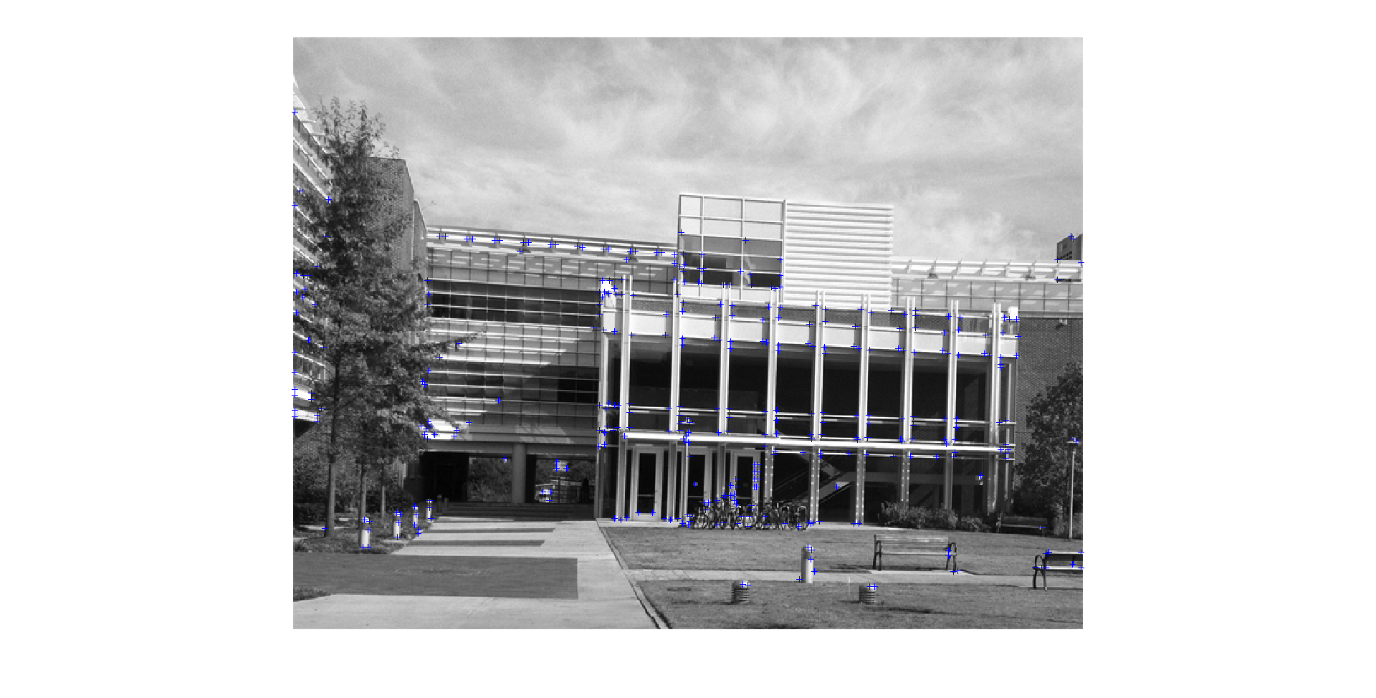

Harris corners of transA highlighted with blue “+” marks. Obtained through finding local maxima after thresholding.

**Problem Set 4, Question 1, Part 3, Image 2**

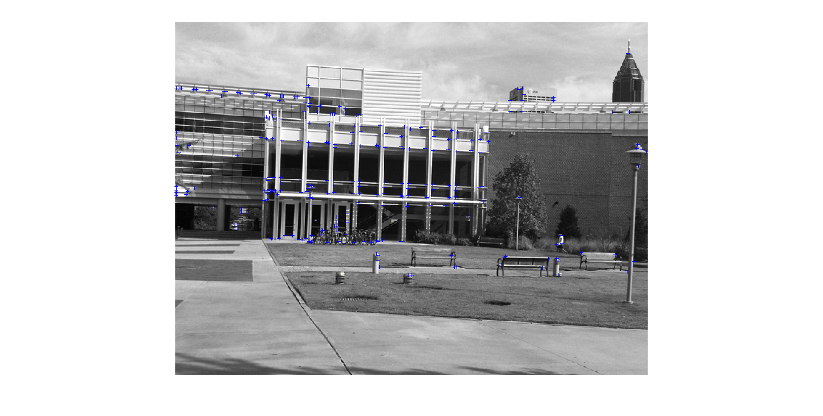

Harris corners of transB highlighted with blue “+” marks. Obtained through finding local maxima after thresholding.

The corner detector successfully detects points where the intensity is changing greatly in both x and y directions. It did notably pickup non-physical corners, like the shadow from the shade projecting on the front doors of Klaus, which generated the densest group of corners in the image. It was notably easier to detect direct sunlight reflections off of round surfaces like the sidewalk lights, since the reflection of the sun created a strong point of bright light surrounded by relatively dark area due to the gray color of the lights.The translation did render a few points found in transB to not be present in transA, notably those on the foreground bench and the top of the lamp in front of the right hand tree. Likewise the corners found on the side protusions and the left hand tree seen in transA are not found in transB.

**Problem Set 4, Question 1, Part 3, Image 3**

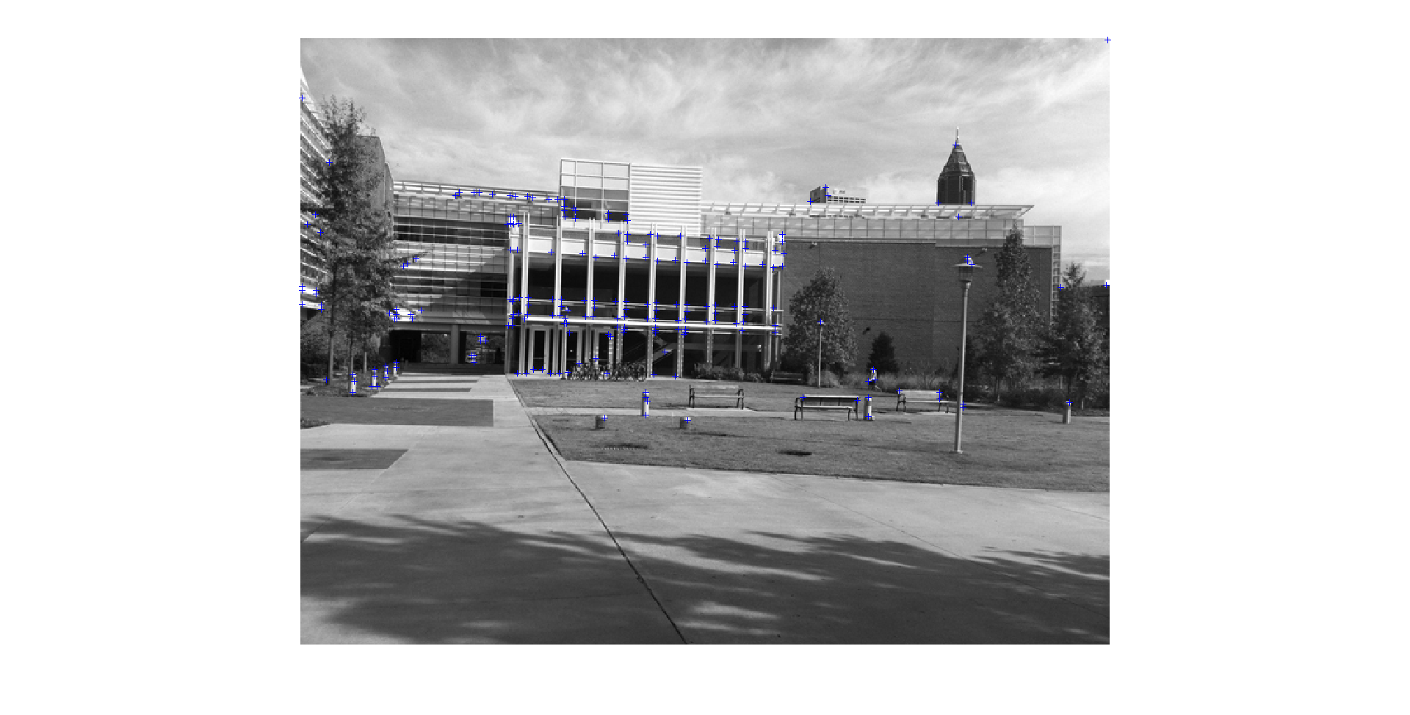

Harris corners of simA highlighted with blue “+” marks. Obtained through finding local maxima after thresholding.

**Problem Set 4, Question 1, Part 3, Image 4**

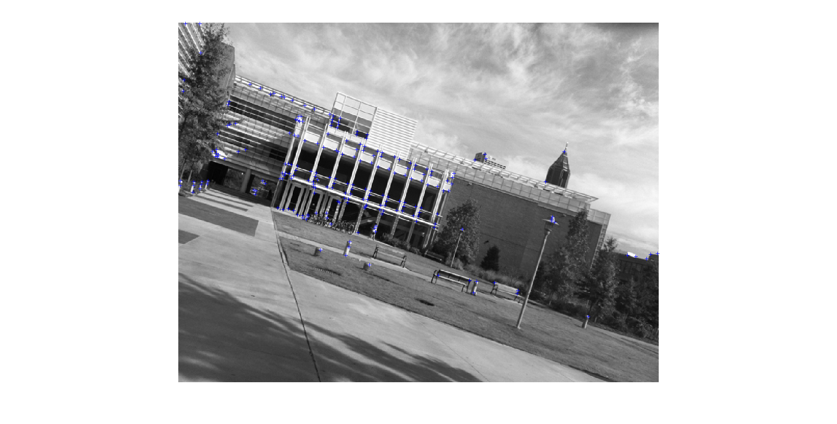

Harris corners of simB highlighted with blue “+” marks. Obtained through finding local maxima after thresholding.

**Problem Set 4, Question 2, Part 1, Image 1**

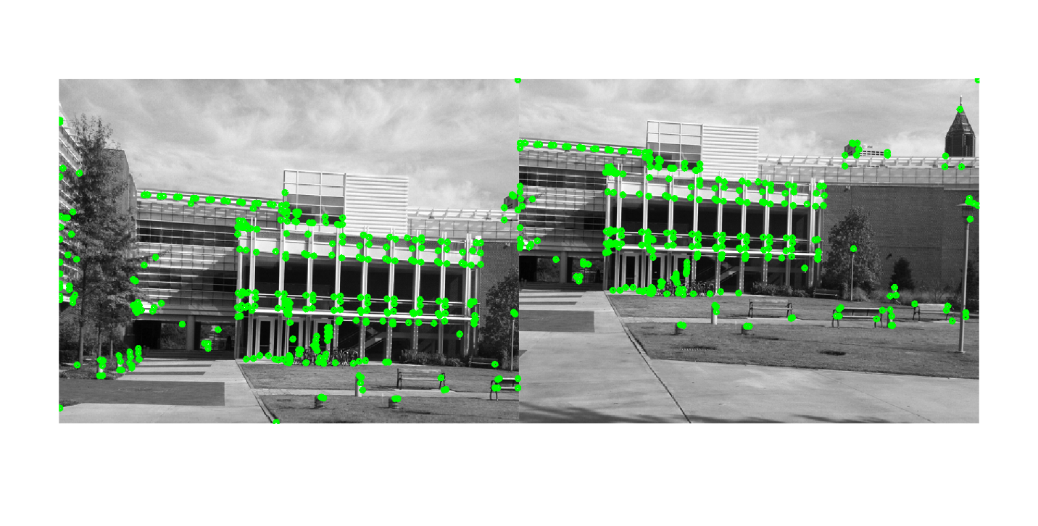

Harris corners marked on transA and transB along with their orientations (it’s somewhat hard to see due to the scale of the individual points).

**Problem Set 4, Question 2, Part 1, Image 2**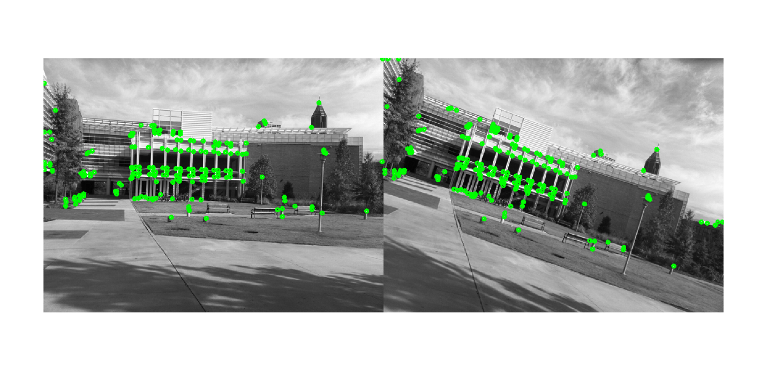

Harris corners marked on simA and simB along with their orientations (it’s somewhat hard to see due to the scale of the individual points).

**Problem Set 4, Question 2, Part 2, Image 1**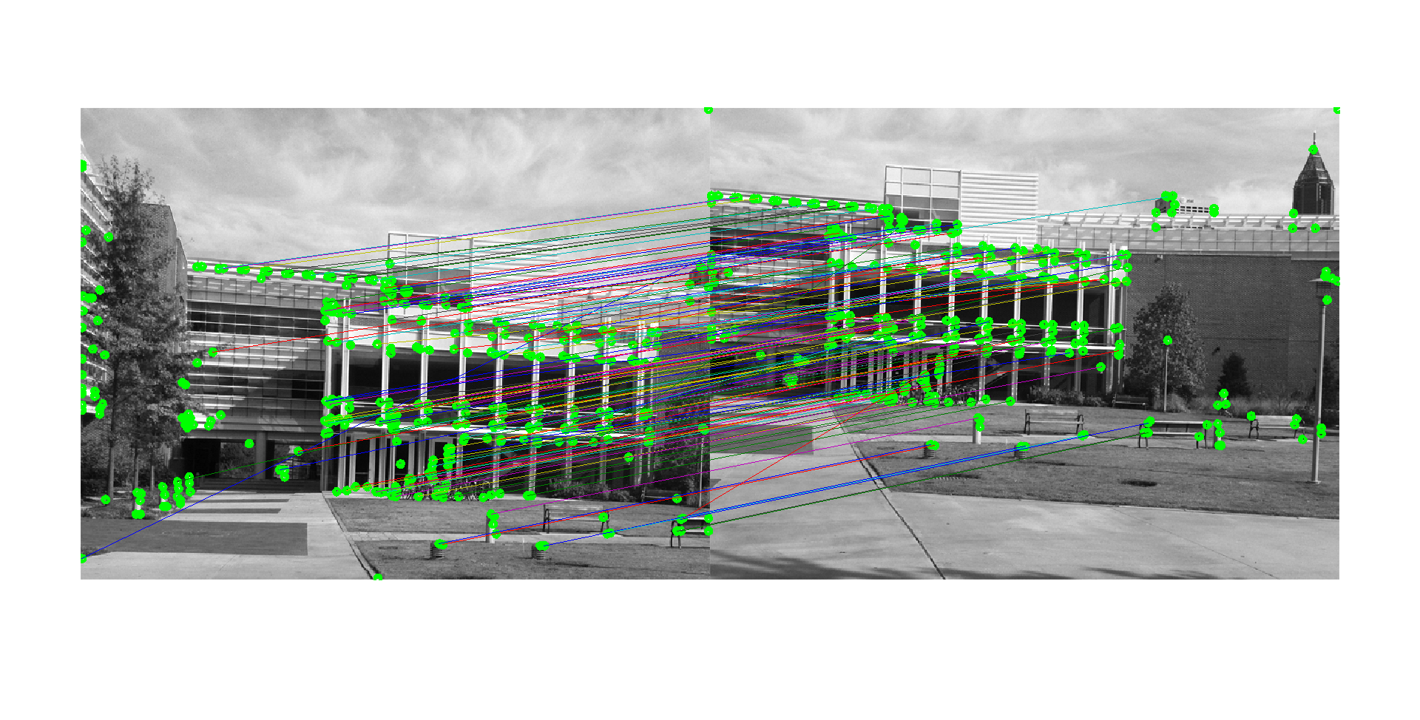

Putative-pair matches for transA and transB, matched by SIFT.

**Problem Set 4, Question 2, Part 2, Image 2**

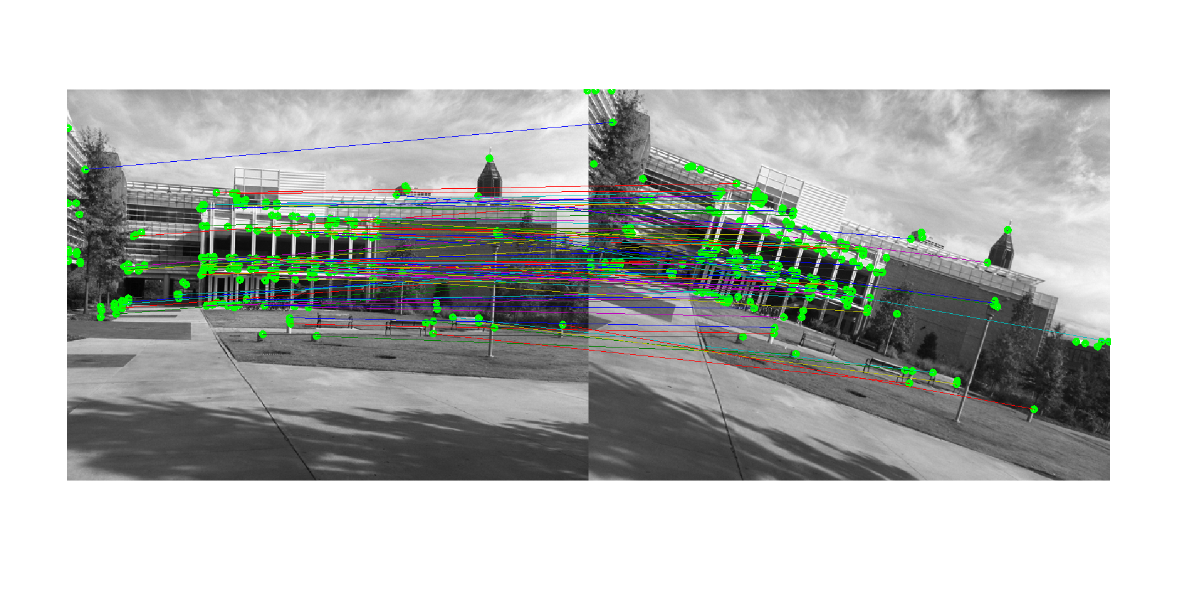

Putative-pair matches for simA and simB, matched by SIFT.

**Problem Set 4, Question 3, Part 1, Image 1**

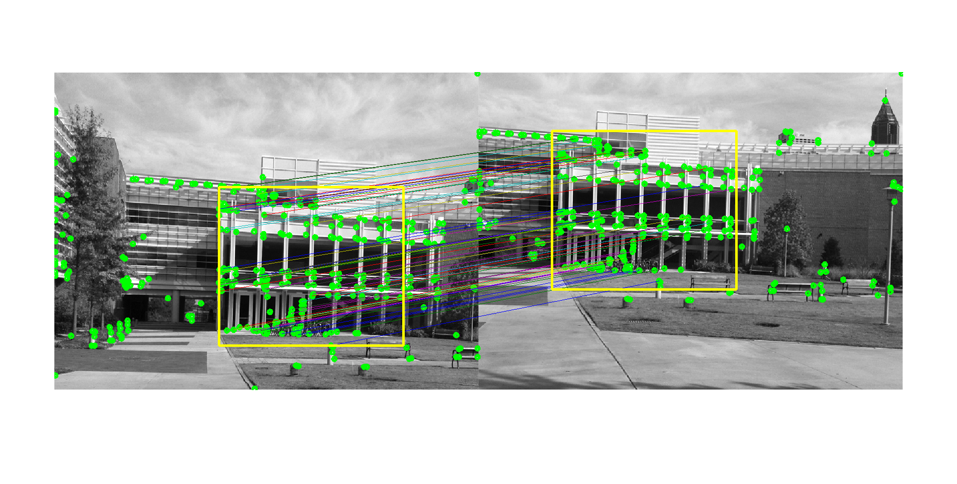

The translation transformation between transA and transB as found through RANSAC. The actual translation is <-136.8971, -86.8088>, and, of the 137 initial putative matches, 49.63% (68) of them were included in the largest consensus set.

**Problem Set 4, Question 3, Part 2, Image 1**

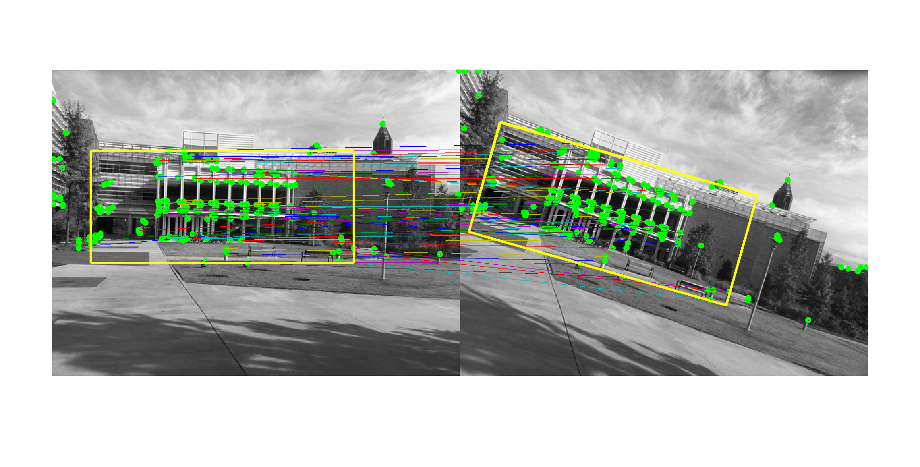

The translation transformation between simA and simB as found through RANSAC. Of the 137 initial putative matches, 49.63% (68) of them were included in the largest consensus set.

The resultant similarity transform matrix is as follows:

0.9791 -0.2816 39.3568

0.2816 0.9791 -59.6810

**Problem Set 4, Question 3, Part 3, Image 1 (extra credit)**

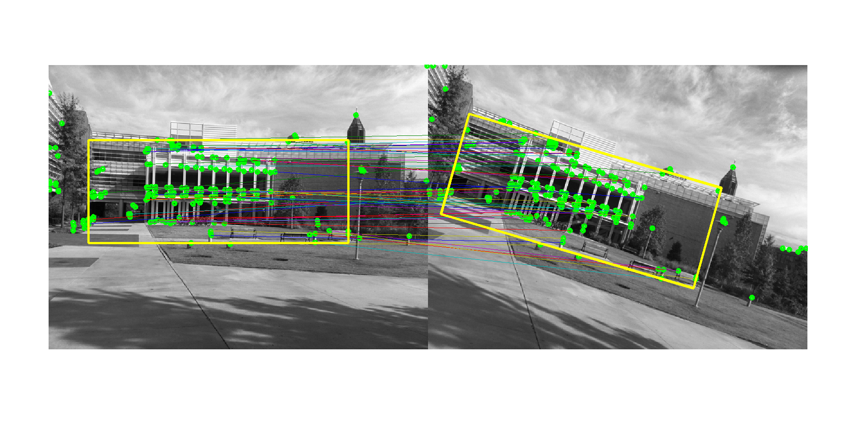

The transform matrix found as a follows:

0.9872 -0.2723 34.9298

0.2861 0.9811 -61.2487

Of the 102 matches found 53.92% (55) of the matches were present in the largest consensus set.

**Problem Set 4, Question 3, Part 4, Image 1 (extra credit)**

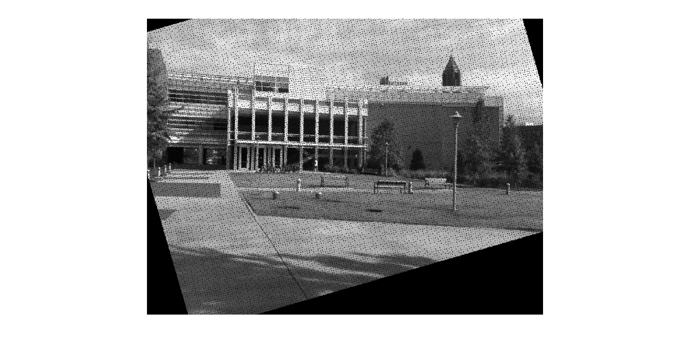

warpedB from the similarity transform found in 3.2.

**Problem Set 4, Question 3, Part 4, Image 2 (extra credit)**

**\**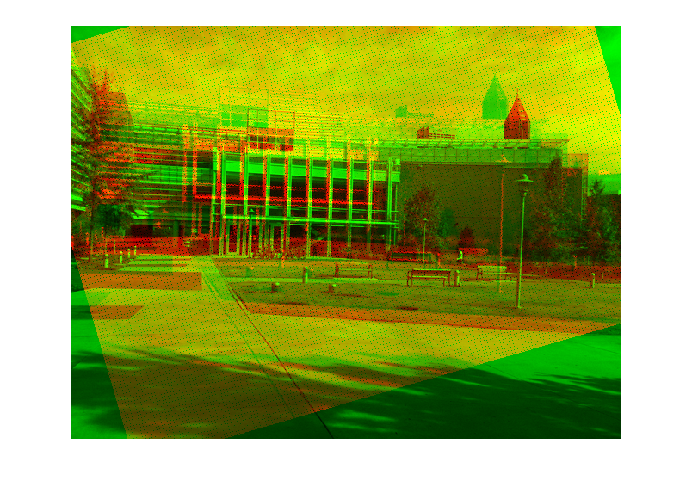

overlay from the similarity transform found in 3.2.

**Problem Set 4, Question 3, Part 5, Image 1 (extra credit)**

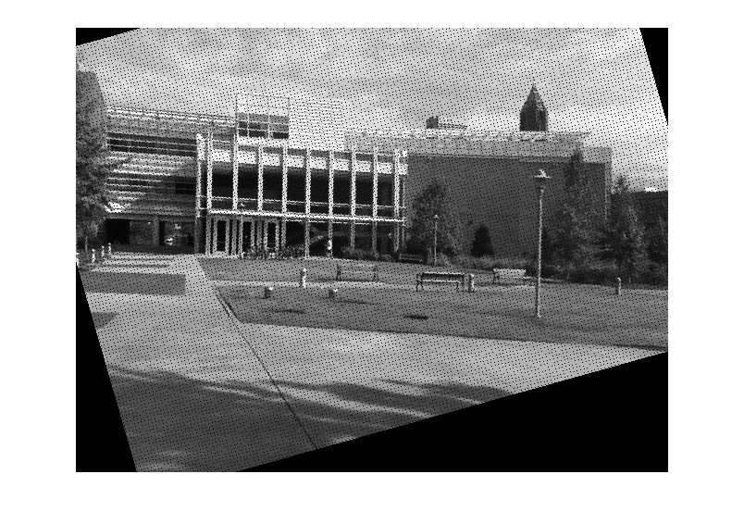

warpedB from the affine transform seen in 3.3.

**Problem Set 4, Question 3, Part 5, Image 2 (extra credit)**

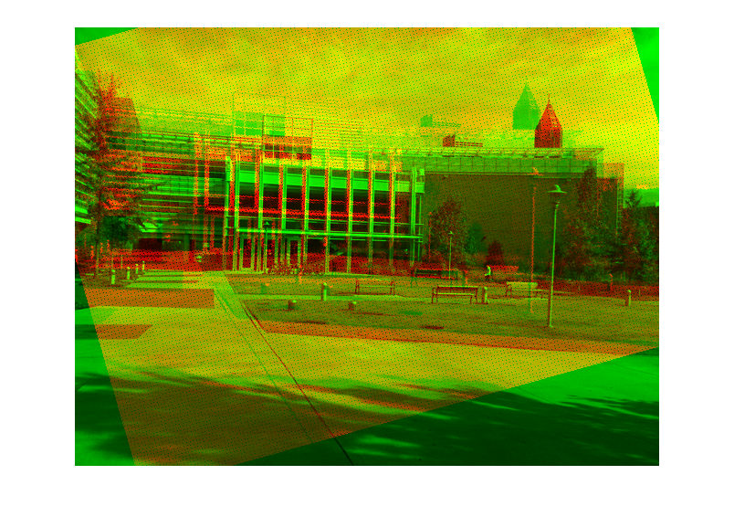

overlay from the affine transform seen in 3.3.

I feel that the affine transform is slightly better. The difference between the two transform isn’t that signfigant, perhaps the true transformation is not too far off from a strict similarity transform, but there are small changes that the affine transform is closer with: notably the skew seen in the transformation of many objects, such as the brick patches in the ground or the foreground bench are closer to how they are in simA.